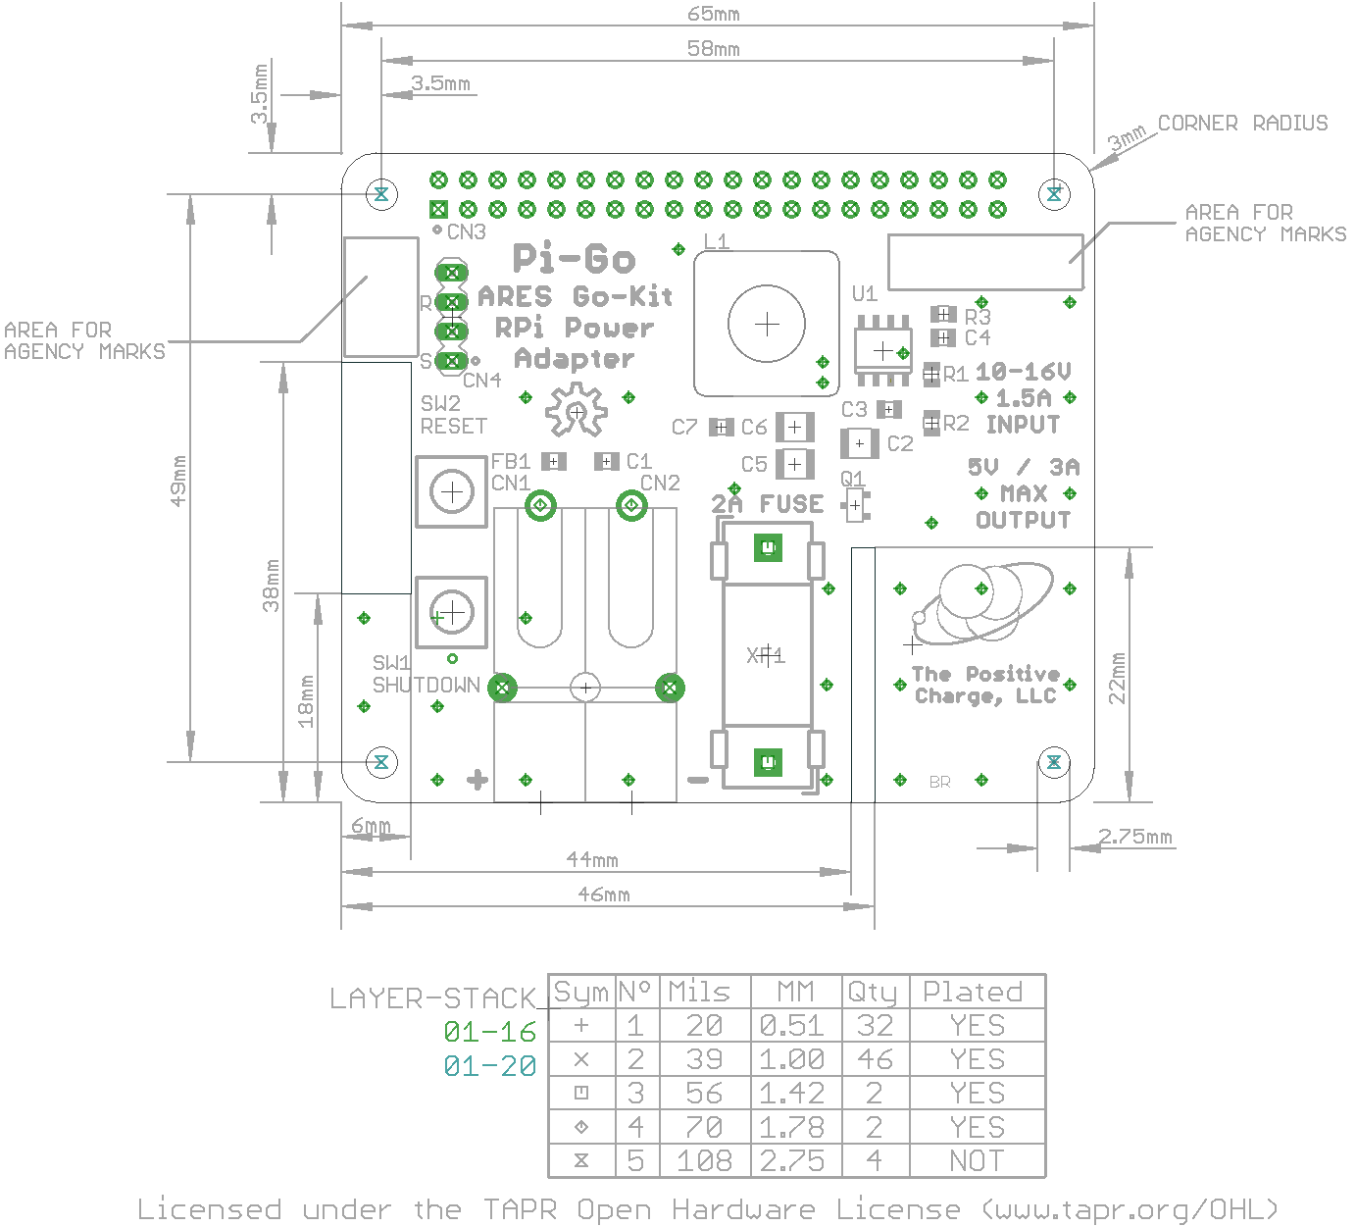
Board dimensions
- Dimensions in mm:
- Rounded corners = 3mm diameter, 4 places
- Milled slots
  - 20mm x 6mm on left edge
  - 2mm x 22mm on bottom edge

Notes:
- Board specifications for selected service level take precedence over these notes.
  - Material: FR-4
    - 1oz Copper External Layer
    - Thickness Tolerance ±0.0061”
  - Solder Mask: Standard Green, SMOBC
  - Vendor shall stamp agency marks on each board as required
  - Silkscreen Color = White, Component layer only
  - All holes size shall be located within 0.003” (0.08mm) diameter of true position from location shown on master pattern.
  - Finished hole size tolerance: ±003” (±0.08mm)
  - Front-to-Back layer registration to be within 0.003” (0.08mm)
  - Board outline shall conform to supplied Gerber data within 0.010” (0.25mm)
  - All internal corners 0.040” (1.01mm) of radius maximum

Board Stack-up – Use standard for service level, or:
All dimensions in inches unless otherwise noted:
Stack-up | Thickness | Tolerance (±) | Layer file ext. | Notes
Layer 1 | 0.0017 | 0.0004 | cmp | Top Layer
Laminate Core | 0.0580 | 0.0025
Layer 16 | 0.0017 | 0.0004 | sol | Bottom Layer
Overall | 0.0614 | 0.0061

